Work 14 Кириленко Константин 351



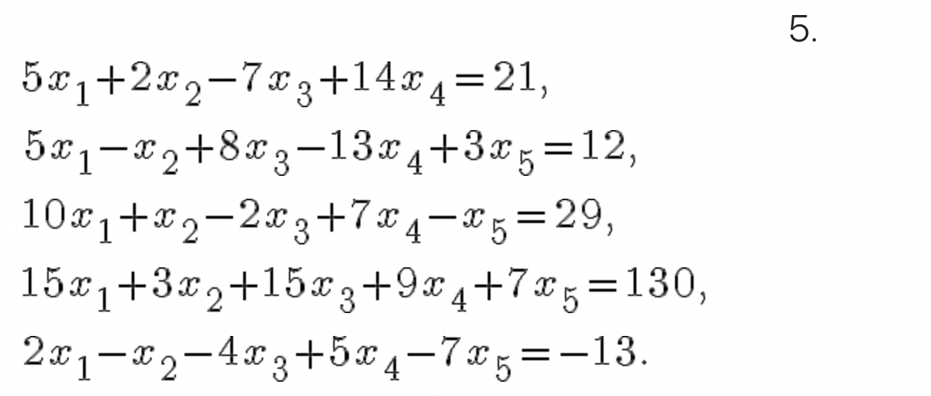

void DummyDataInitialization(double\*\* pMatrix, double\* pVector, int Size) {

pVector[0] = 21;

pVector[1] = 12;

pVector[2] = 29;

pVector[3] = 130;

pVector[4] = -13;

pMatrix[0][0] = 5;

pMatrix[0][1] = 2;

pMatrix[0][2] = -7;

pMatrix[0][3] = 14;

pMatrix[0][4] = 0;

pMatrix[1][0] = 5;

pMatrix[1][1] = -1;

pMatrix[1][2] = 8;

pMatrix[1][3] = -13;

pMatrix[1][4] = 3;

pMatrix[2][0] = 10;

pMatrix[2][1] = 1;

pMatrix[2][2] = -2;

pMatrix[2][3] = 7;

pMatrix[2][4] = -1;

pMatrix[3][0] = 15;

pMatrix[3][1] = 3;

pMatrix[3][2] = 15;

pMatrix[3][3] = 9;

pMatrix[3][4] = 7;

pMatrix[4][0] = 2;

pMatrix[4][1] = -1;

pMatrix[4][2] = -4;

pMatrix[4][3] = 5;

pMatrix[4][4] = -7;

}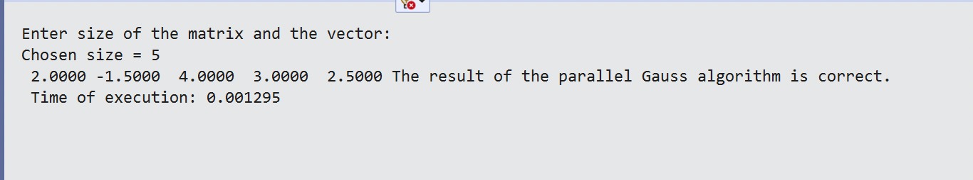

Решение с помощью метода Гаусса верно.

